**IOT BASED HOME AUTOMATION**



**DEPARTMENT OF ECE**

**GURU NANAK INSTITUTE OF TECHNOLOGY, MULLANA**

**AFFILIATED TO**

**KURUKSHETRA UNIVERSITY,KURUKSHETRA,HARYANA**

**BATCH 2015-2019**

**Submitted By : Submitted To :**

Manish Kumar Miss Harmanpreet Kaur

Rabin Mandal Assistant Professor

Vinay Kumar

* **Introduction :**

The main objective of this project is to develop a home automation system using an Node MCU board with Internet being remotely controlled by any Android OS smart phone. As technology is advancing so houses are also getting smarter. Modern houses are gradually shifting from conventional switches to centralized control system, involving remote controlled switches. Presently, conventional wall switches located in different parts of the house makes it difficult for the user to go near them to operate. Even more it becomes more difficult for the elderly or physically handicapped people to do so. Remote controlled home automation system provides a most modern solution with smart phones.

* **Block Diagram :**

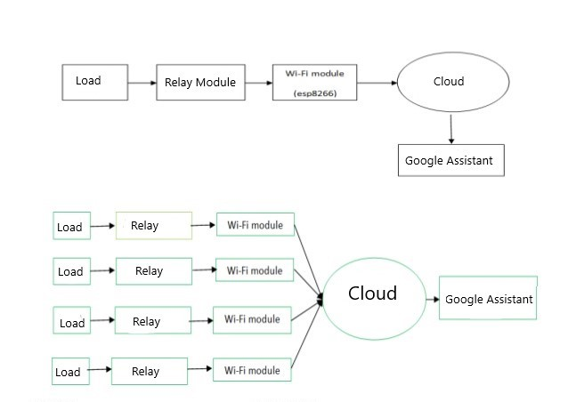

* **Theory :**

In order to achieve this, a relay module is interfaced to the Node MCU board at the receiver end while on the transmitter end our famous AI Bot by Google Inc. named Google Assistant on the smart phone sends ON/OFF commands to the receiver where loads are connected. By speaking or typing the specified commands on the Google Assistant, the loads can be turned ON/OFF remotely through this technology. The loads are operated by IOT board through Relay Module.

* **Components Used :**

1. NODE MCU ESP 8266 Board
2. 4 Channel Relay Module
3. Light Buld
4. LED Bulb
5. Small Fan
6. Buzzer

* **Estimated Cost :**

The estimated cost of the this minor project is : **Rs. 1500**

* **Applications :**

1. [Heating, ventilation and air conditioning](https://en.wikipedia.org/wiki/HVAC) (HVAC) : it is possible to have remote control of all [home energy monitors](https://en.wikipedia.org/wiki/Home_energy_monitor) over the internet incorporating a simple and friendly user interface
2. [Lighting control system](https://en.wikipedia.org/wiki/Lighting_control_system): a "smart" network that incorporates communication between various lighting system inputs and outputs, using one or more central computing devices.
3. Home robots and security: a household security system integrated with a home automation system can provide additional services such as remote surveillance of security cameras over the Internet, or access control and central locking of all perimeter doors and windows.
4. Leak detection, smoke and CO detectors
5. Indoor positioning systems (IPS).
6. Home automation for the elderly and disabled.